Order Of Service

Singing: Psalm 121—CW page 112

Reading: Psalm 107:1-22

Opening Hymn: TLH 657

Reading: Hebrews 6:1-20

Request Hymn: CW Supplement 707

Reading: Luke 7:36-50

Sermon Hymn: TLH 339

Sermon Text: Acts 8:9-13

Simon Baptized

Prayer

The Apostles’ Creed, TLH page 12

Holy Communion

The Lord's Prayer

The Blessing

Closing Hymn: TLH 578

************

Bible Study: Lambs: Albatross
Sheep: Deut. 13:12-18
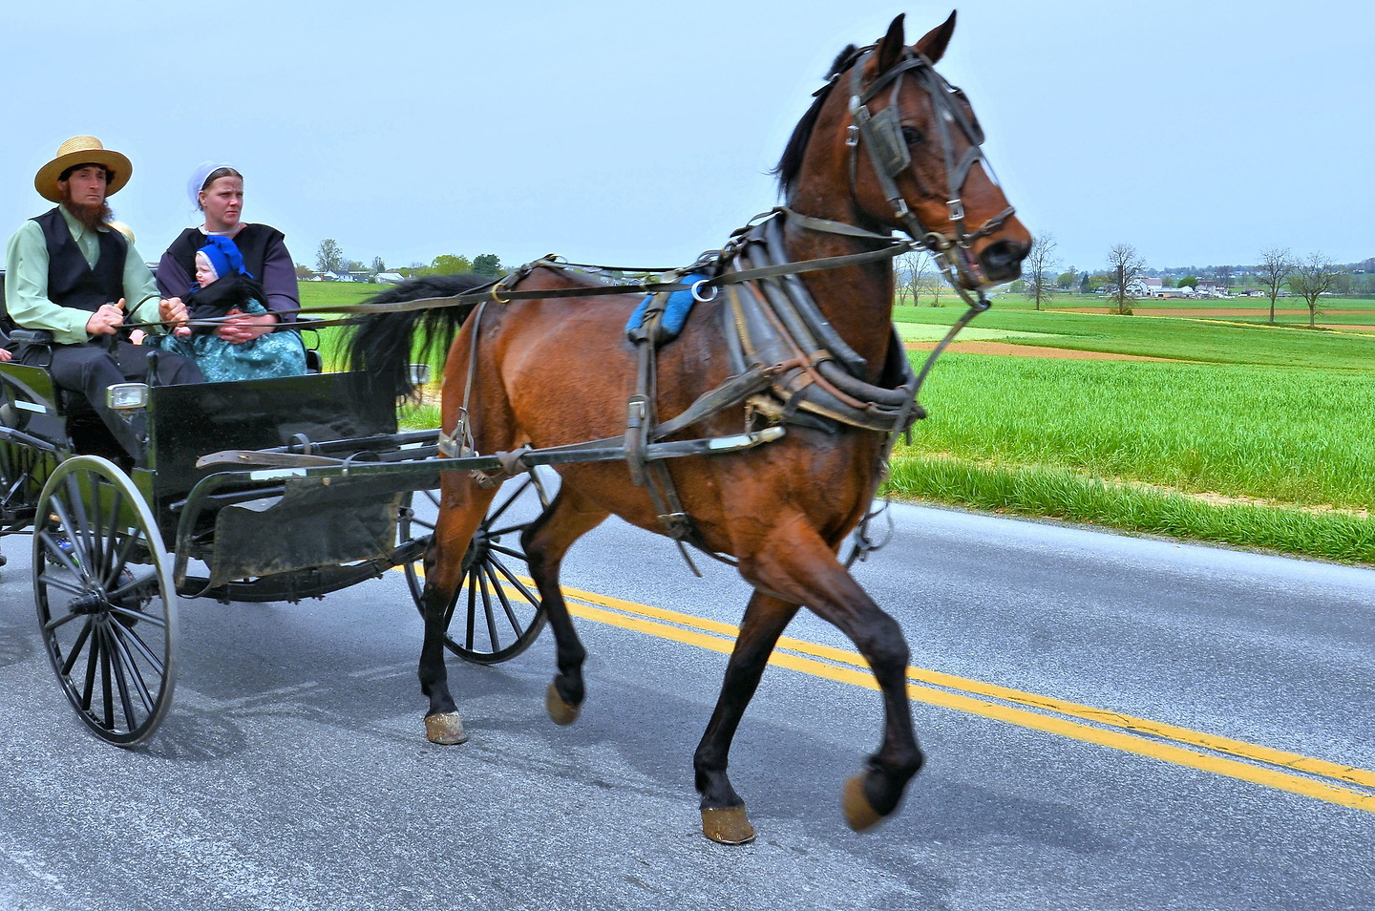

Amish One Horse Power

Water
Of
Life

22 September 2024

W A T E R O F L I F E

Independent Christian Church—Conservative Lutheran Doctrine

Worship Service: 9:30 a.m.

Larry Cooper, Pastor E-Mail address:
lcooper@wateroflife.cc
Web Site:
www.wateroflife.cc

* * * * * * * * * * * * * * * * * * * * * * * * * * *

Sermon Text: Acts 8:9-13

Simon Baptized

* * * * * * * * * * * * * * * * * * * * * * * * * * *
9 But there was a certain man, called Simon, which beforetime in the same city used sorcery, and bewitched the people of Samaria, giving out that himself was some great one:
10 To whom they all gave heed, from the least to the greatest, saying, This man is the great power of God.
11 And to him they had regard, because that of long time he had bewitched them with sorceries.
12 But when they believed Philip preaching the things concerning the kingdom of God, and the name of Jesus Christ, they were baptized, both men and women.
13 Then Simon himself believed also: and when he was baptized, he continued with Philip, and wondered, beholding the miracles and signs which were done.



